**ASSIGNMENT - 4**

1.Pull an image from docker hub and run in docker playground.

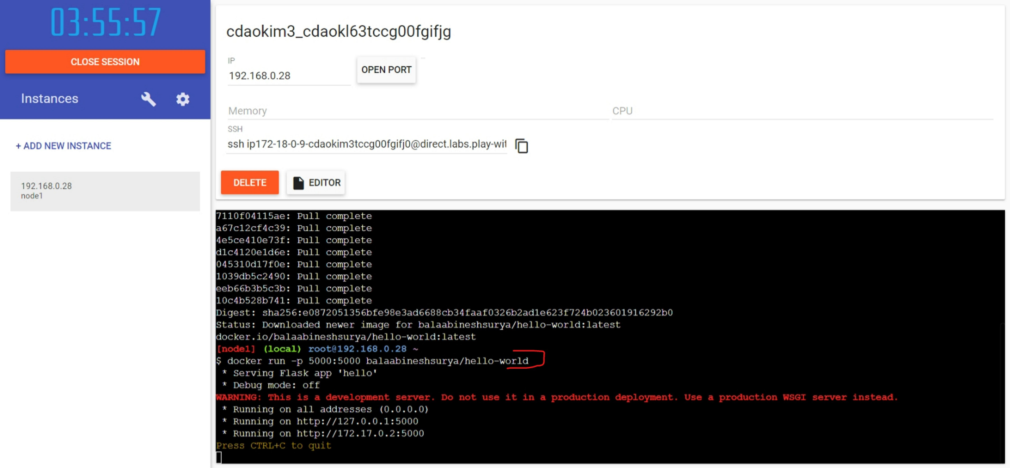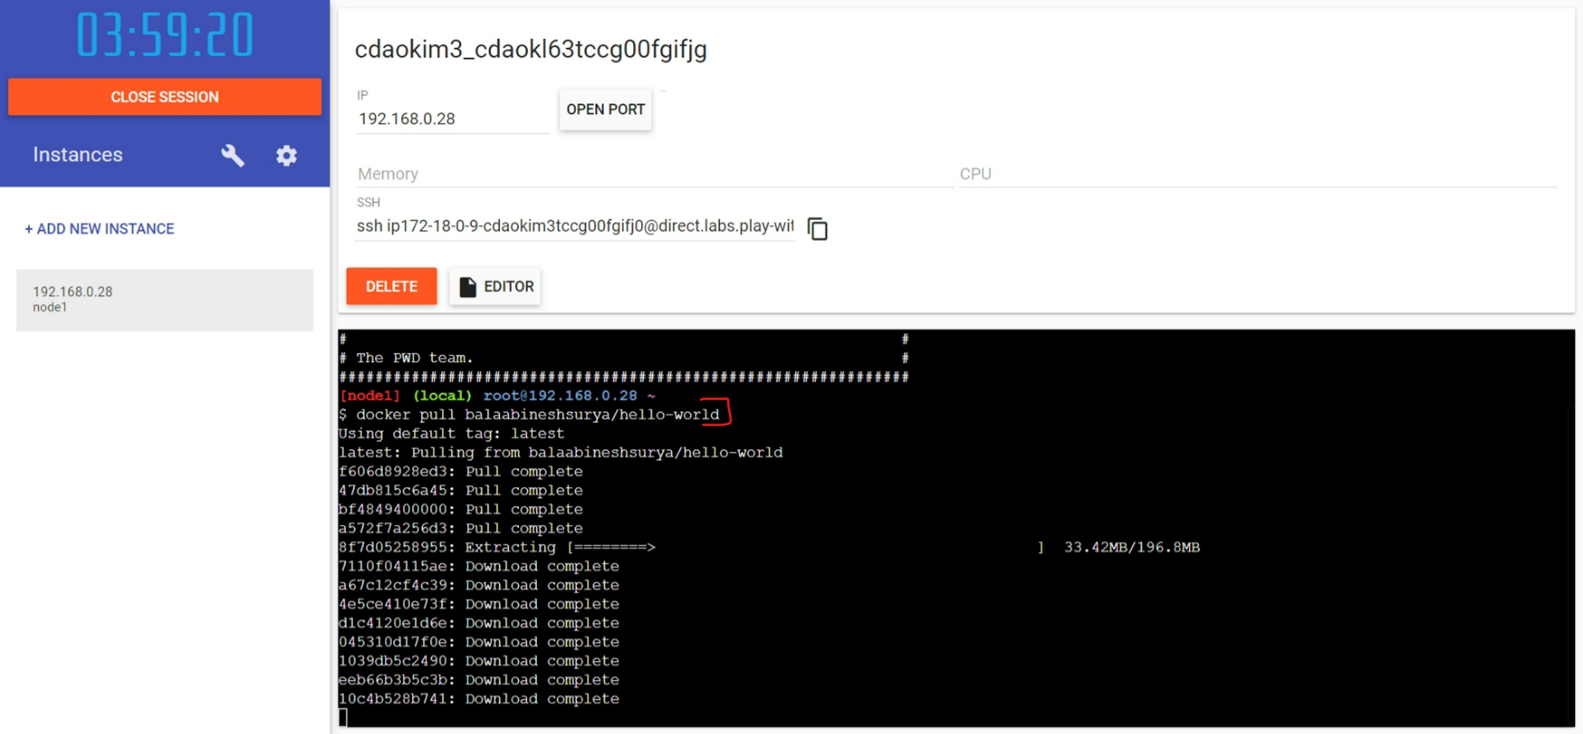

**Output:**

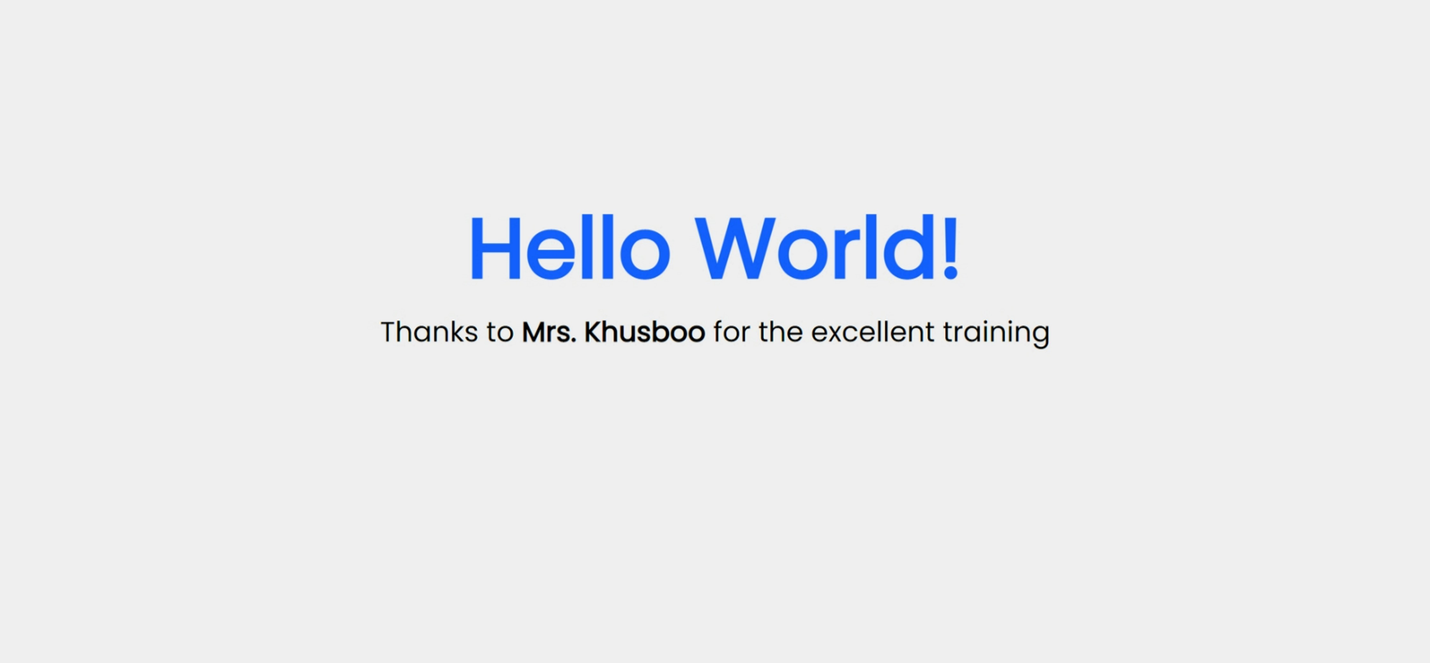

2. Create a IBM container registry and deploy hellowworld app or jobportal app.

